About our Scout Group
- All Leaders and supporters are voluntary and receive no payment whatsoever.
- Behind the scenes there is a team of parents and friends helping to provide what the Group needs to flourish.
- We’re fortunate to have our own top quality Scout Centre for meetings and activities. We also hire out the Centre to other organisations and individuals for parties, dances & functions.
- The Scout Centre is completely self-funding. This means that all our fundraising goes towards activities for the youngsters.
- We run our own minibus, camping equipment, canoes, games and activity equipment.
- We usually hold two fund-raising activities a year, a Summer Fayre and Christmas Grotto. We also hold family fun events such as a Quiz Night, Barbecue and Parents Open Night.

Group Executive Committee
We have a Group Committee that organises these events and supports the Scout Group. The Group Committee comprises of parents, leaders and friends of the Scout Group.

All of this helps us provide top quality Scouting for your child. We ask parents to help us to achieve this – any time and help you can give us will be appreciated.
We’re proud of our Scout Group and welcome everyone to join in our success.

Welcome to Romsley
St. Kenelm’s Scout Group

There are over 500,000 Scouts in the UK
and 31 million all over the world.
Our Scout Group has three sections …

S
University College Birmingham

6 – 8 years
Meet every Monday 6.00 to 7.30pm


8 – 10½ years
Meet every Tuesday 7.00 to 8.30pm


10½ - 14 years
Meet every Friday 7.30 to 9.30pm


Group Executive

Committee Members

Treasurer


Scout Network
18 – 25 years

Group Executive
Meets every 2 months,
2nd Monday of the month
Explorer Scouts 14 – 17 years
Membership Fee
We have a subscription of £33 per term.
This goes towards the costs of meetings - badges, games, refreshments, handicrafts, and so on. We also pay an annual membership fee to the Scout Association out of this, currently £38 for each youngster every year.
We hold fund-raising events to subsidise our activities and keep the cost down for parents.

Youngsters then move onto Explorer Scouts or become Young Leaders.
S

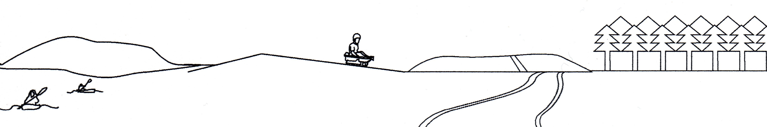
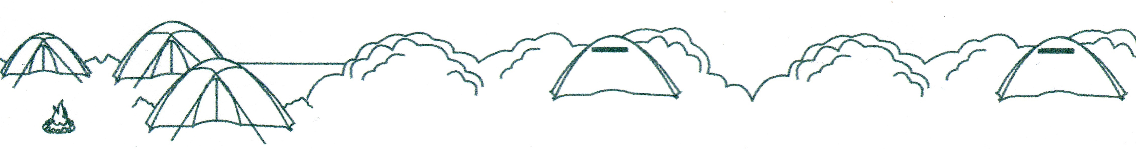
Uniform
Here is our uniform for when your child is sure that they want to join.
Being invested
Once your child has their uniform they will be invested.
This is a simple ceremony when they will take their Promise and be presented with their first badges and neckerchief



Membership
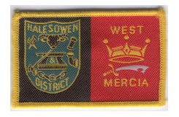
District & County
Turquoise Sweatshirt
Optional – Polo shirt and baseball cap



Group Name


Green Sweatshirt
Optional - Navy Blue Activity Trousers or Skirt, Polo shirt and baseball cap

Beaver Scout Promise
I promise to do my best
to be kind and helpful
and to love God.




Teal Green Shirt
Navy Blue Activity Trousers or Skirt & Scout Belt

Cub Scout Promise
I promise that I will do my best,
to do my duty to God and to The Queen,
to help other people
and to keep the Cub Scout Law.



For full details go to www.scoutshops.co.uk

Items of uniform can be bought from:

Scout Promise
On my honour, I promise that I will do my best,
to do my duty to God and to The Queen,
to help other people
and to keep the Scout Law.

Alternative wording is available for different faiths


- Dancers Menswear Peckingham Street, Halesowen. B63 3AR
- Bromsgrove Sports 1 Church Street, Bromsgrove B61 8DD
- A.Oakes Ltd 174 Vicarage Road, Oldbury B68 8JB
- School Shop 54 High Street, Stourbridge DY8 1DE
Online
- Scout Shops www.scouts.org.uk/shop

.
Where do the badges go?
Badges

Your son or daughter can gain a number of badges during their time in the Group.

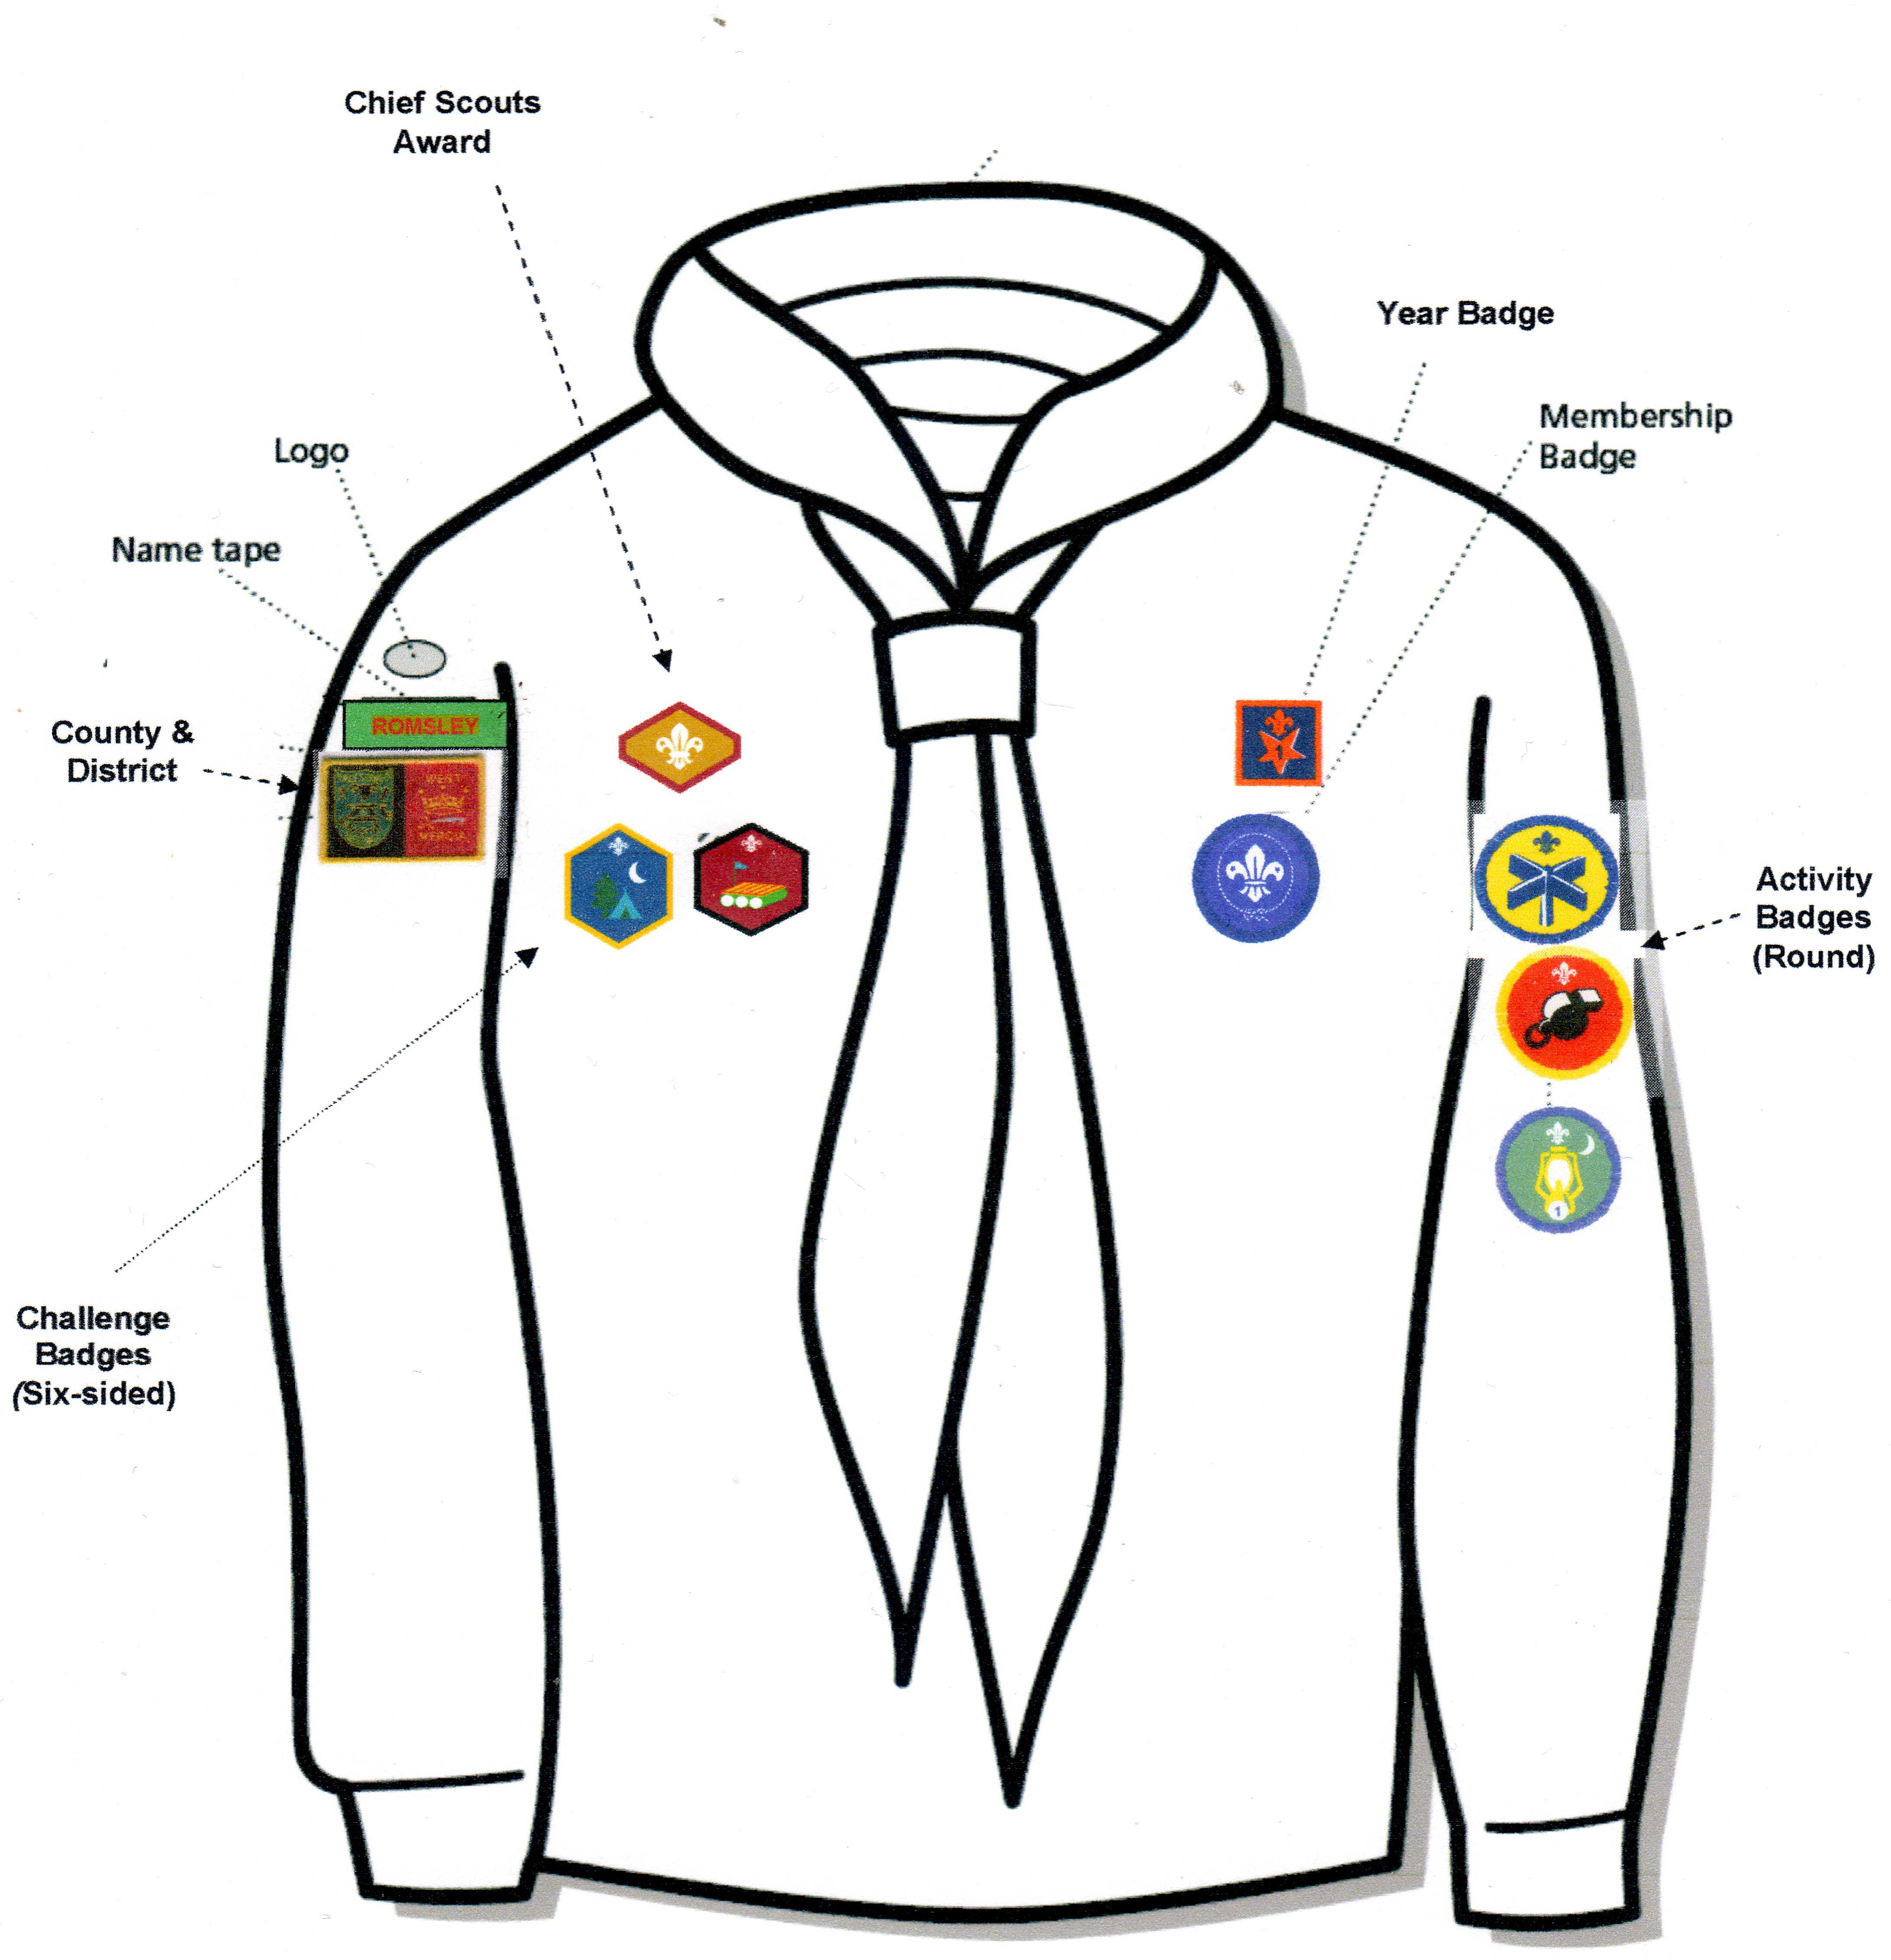
Challenge Badges
Six sided - worn on front


Activity Badges
Covering hobbies & interests
Chief Scouts Award
Beavers – Bronze, Cubs – Silver, Scouts - Gold



Year Badge
One for every year in the Group
Moving On Award
When a youngster moves onto another section


Contact Info
- General Andy Shepherd 01527 831811
- Beavers Kate McDonnell 07878 865395
Emma Pickford-Perry 07437 543383
- Cubs c/o Andy Shepherd 01527 831811
Gary Hawksford 07500 925995
- Scouts Alastair Grant 01384 571705
Ian Grant 01384 571705
Rory Scott 0121-550 6070
- Committee Alex Perry 0121-585 9939
- Scout Centre Hire Pat Rae 07898 995226
- Group e-mail romsleyscouts@hotmail.com
Further information on our website www.romsleyscouts.org.uk
Find us on Facebook at www.facebook.com/romsleyscoutgroup



